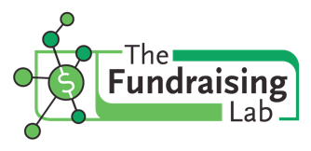
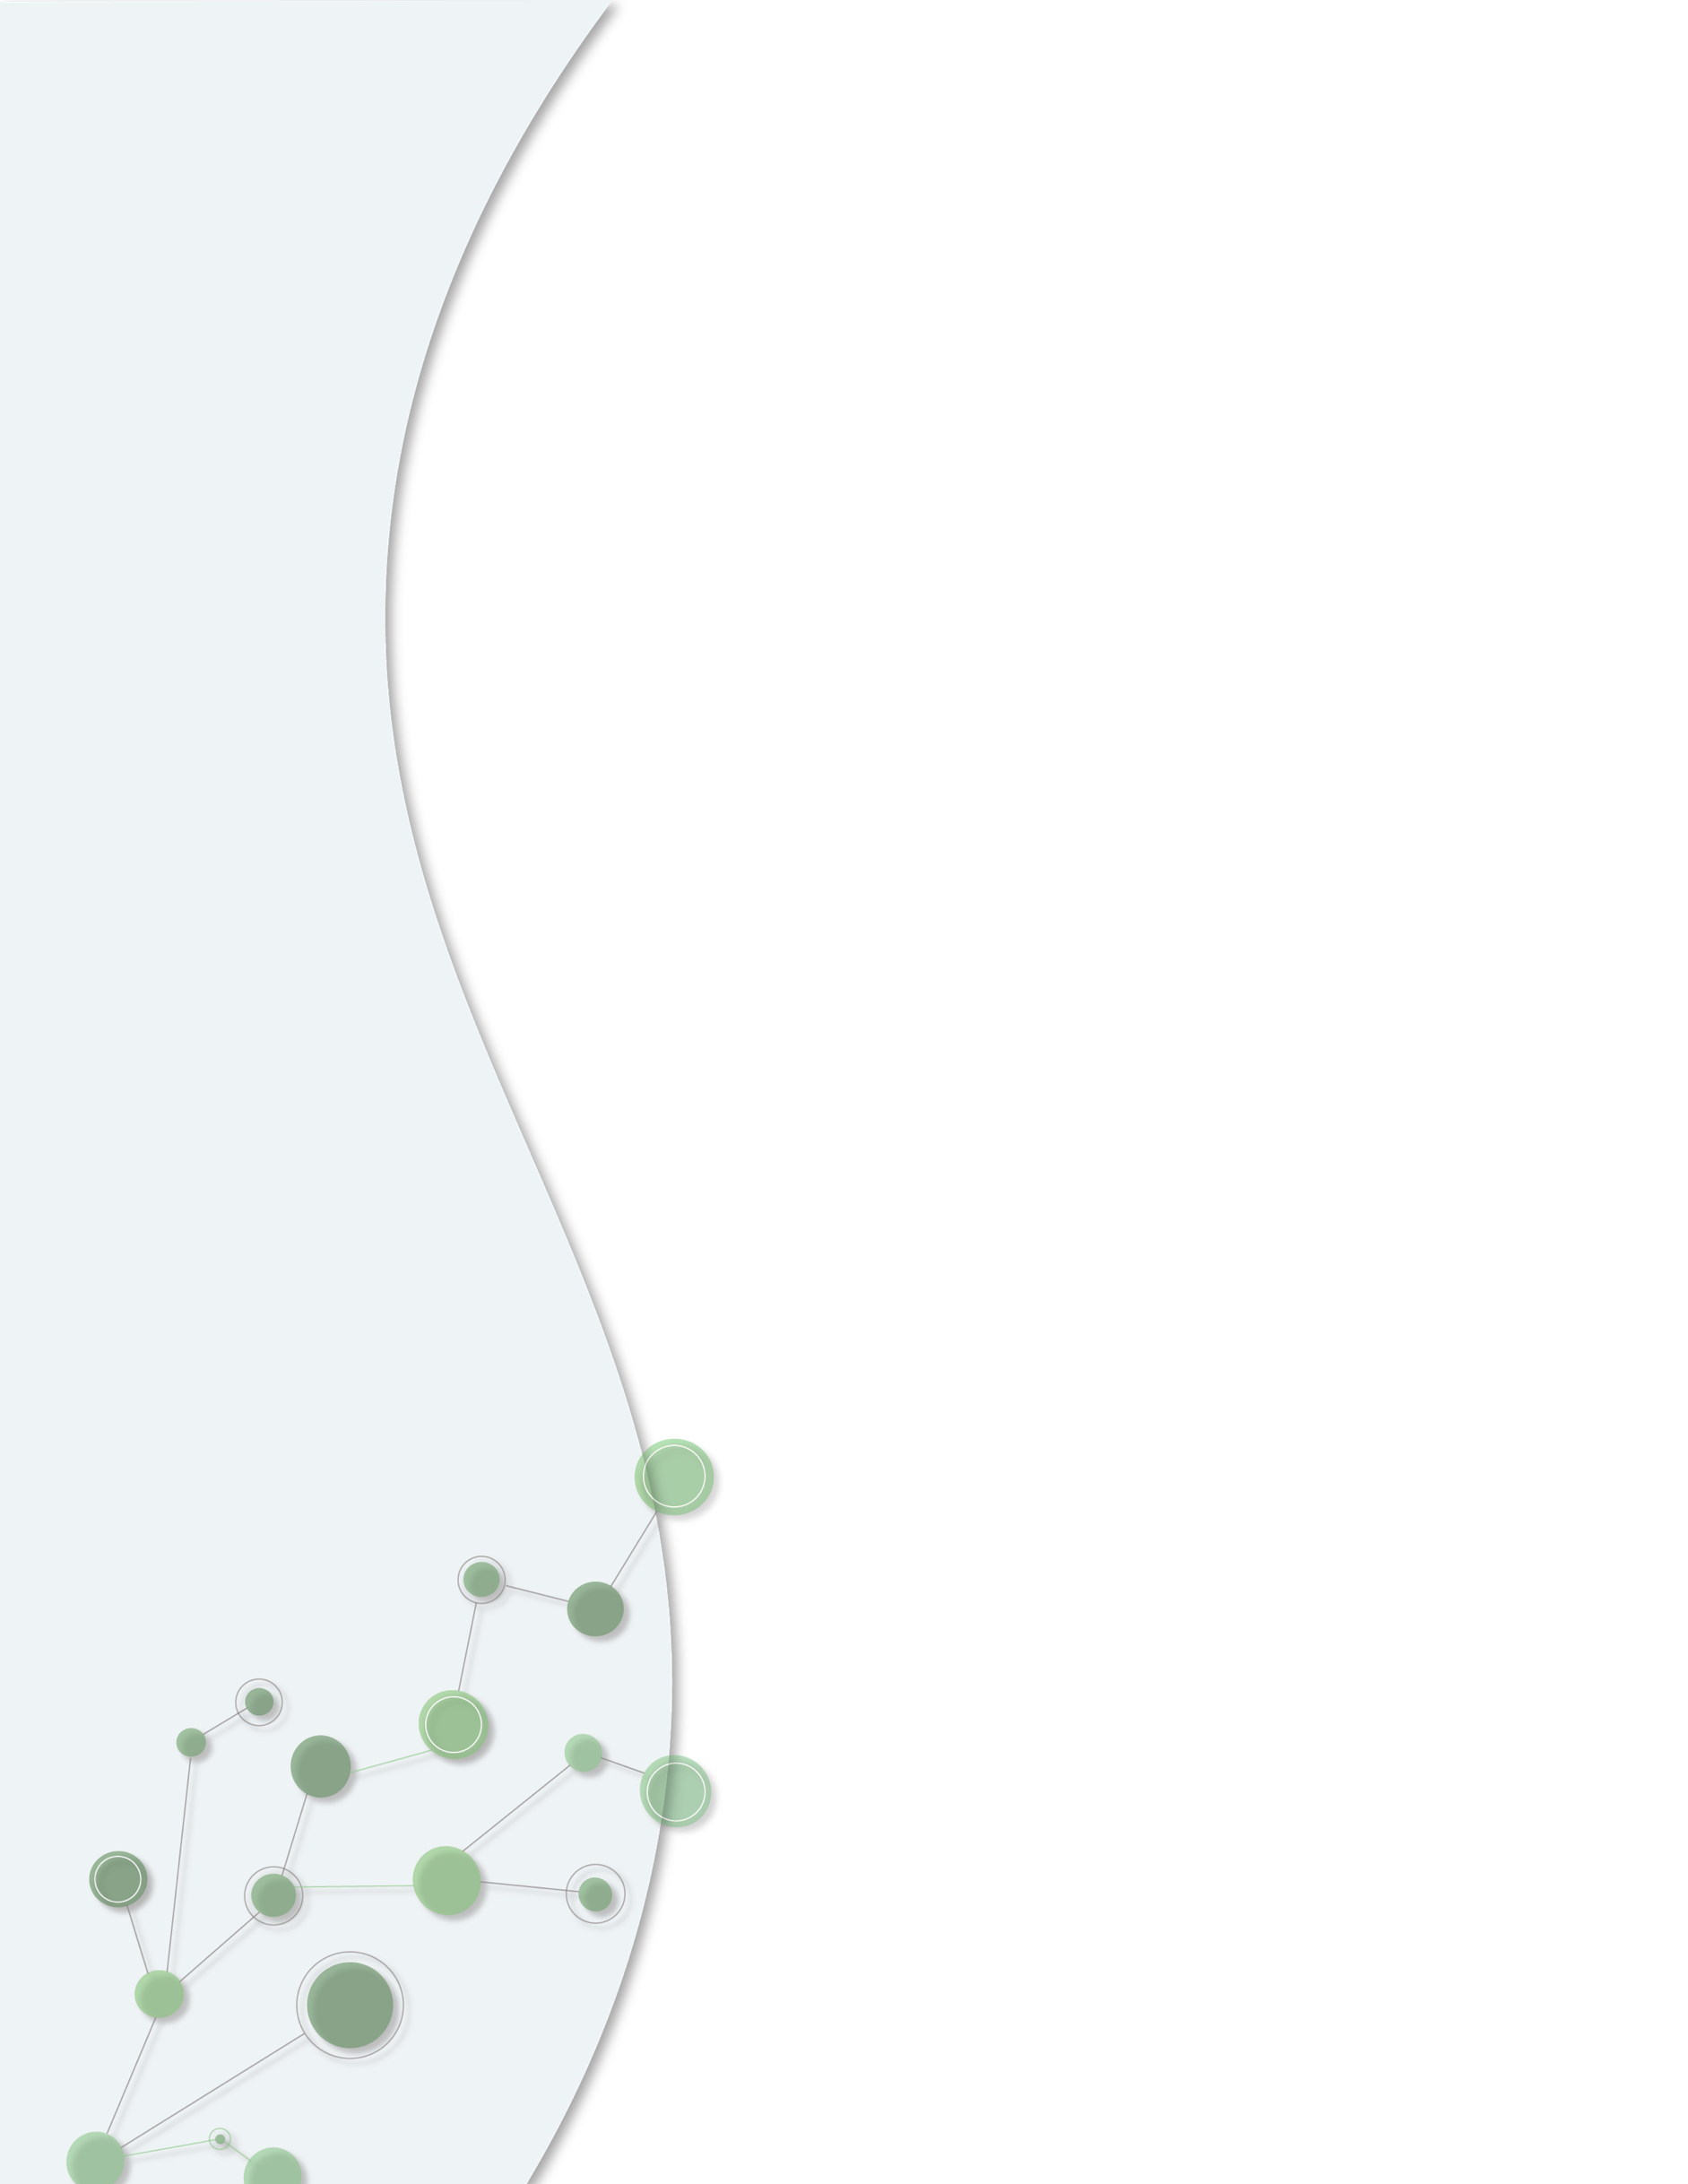
Program Developed by
The Fundraising Lab

Beginning Monday, April 25, 2021

Planning with Purpose

Transform Your Fundraising in 8 Weeks
www.fundraisinglab.ca

Planning with Purpose
Transform your Fundraising in 8 Weeks

Introduction

The need for your services is soaring, but you need funds to better serve your community. You’re making a difference, but you want to make an impact.
The reality is that you’re spread thin. You’re working solo or have a small team and you’re tapped out. Your systems and processes are lacking efficiency. Your relationships with donors could be stronger. Your board isn’t responsive to your efforts. And you’re putting out fires and not getting to the crux of your work.
You know what you want to accomplish but it feels overwhelming.
So where do you begin…
You begin with a program created to help you work through your roadblocks. You begin with Planning with Purpose.
Over 8 weeks, you will learn to create, communicate and carry out an achievable, actionable and adaptable plan that will transform the way you fundraise.
Key Information
- Cost: $849.00 CAD
- Delivery: self-paced
- Timing: We designed the course to run for 8 weeks but feel free to take as short or as long as you need
- Access: Lifetime access to all course materials and recordings
Course Outline

WEEK 1
Modules 1 & 2 - Getting Started
Introduction – 30 minutes
1.0 Meet Cathy, your Fundraising Guide
1.1 Welcome to the Course!
1.2 The Importance of Having a Plan
1.3 The Learning Approach
1.4 Some Context

Fundraising's Enabling Ecology Framework – 30 minutes
2.0 Creating the Enabling Ecology in Support of Fundraising

WEEK 2
Module 3

The Fundraising Plan – 5 minutes
3.0 The 5 Steps to Developing Your Fundraising Plan

Step 1: Inventory Taking – 25 minutes
3.1 Inventory Taking

WEEK 4
Module 3

Step 2: Filling Out the Fundraising Plan Template - 90 minutes
3.2.a The Fundraising Plan Template
3.2.b Details of the Fundraising Plan Template
3.2.c The Interconnectedness of the Fundraising Plan, Budget and Donor Database
3.2.d Intro to Do Good’s Fundraising Plan
3.2.e Inputting Fundraising Strategies
3.2.f Inputting Infrastructure

WEEK 5
Module 3

Steps 3-5: What to Keep, Improve, and Add to Your Plan – 30 minutes

3.3 What will you keep: Fundraising Strategies and Infrastructure
3.4 What will you improve
3.5 What will you add

Week 6
Module 3 - Keep working on your fundraising plan

Week 7
Module 4

The Budget – 60 minutes
4.1 Creating Your Budget
4.2 Fundraising Revenue
4.3 Legacy Giving Revenue
4.4 Expenses and Net Revenue
4.5 The Three Types of Revenue
4.6 Cost Per Dollar Raised

Week 8
Modules 5-7

Pulling it All Together – 105 minutes
5.0 Pulling it All Together
6.0 Getting Buy-in (including simulated presentation to the Board of Directors)
7.0 The Fairy Dust

After the plan: at your own pace

Master Classes - 90 minutes
The Executive Director’s Role in Philanthropy
The Board of Director’s Role in Philanthropy

Workshops - 120 minutes
How to configure your fundraising database
The basics of writing a case statement

Note: If you are working towards your CFRE designation, AFP has given this course 12.25 points which you can put towards your certification.

